BROWN LENSES

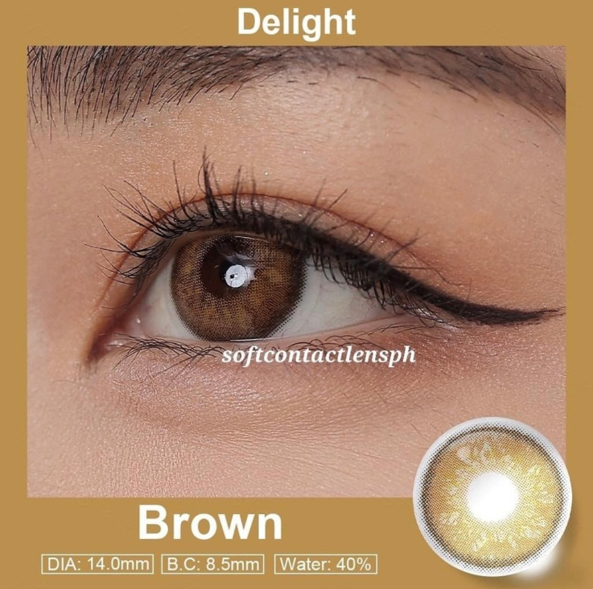

**DIA: 14.0mm**

**B.C: 8.5mm**

**WATER: 40%**

Brown contact lenses are a type of colored contact lenses that are designed to mimic or enhance the natural brown color of the eyes. These lenses are popular among individuals who want to change their eye color or add depth and warmth to their existing brown eyes. Brown contact lenses are available in various shades and designs, ranging from subtle enhancements to more dramatic and vibrant options. They are typically made from soft, breathable materials such as silicone hydro gel which ensure comfort and allow for proper oxygen flow to the eyes. It is important to note that brown contact lenses, like any other contact lenses, should be prescribed and fitted by a qualified eye care professional. They will assess your eye health, provide a proper fitting, and guide you on the safe and appropriate use of these lenses based on your individual needs and eye condition. Proper care and maintenance of brown contact lenses are essential to ensure eye health and comfort. They should be cleaned and stored according to the instructions provided by the manufacturer or your eye care professional. It is also important to follow the recommended wearing schedule and replace the lenses as directed to avoid any potential complications. If you are considering using brown contact lenses, it is highly recommended to consult with an eye care professional that can provide personalized advice and guidance based on your specific requirements.